Bahria University,

Karachi Campus



LAB EXPERIMENT NO.

**04**

LIST OF TASKS

|  |  |
| --- | --- |
| TASK NO | OBJECTIVE |
| 1 | **Make a Calculator! using prompt(), and variables, make a program that does the following: i Prompts the user for first number. ii Stores that first number iii Prompts the user for the second number Iv Asks which operation does it want to perform (+,-,/,*,++,--,%) V Stores that result and responds with the calculated value by using an alert.** |
| 2 | **var array = ["Banana", "Apples", "Oranges", "Blueberries"]; 1. Remove the Banana from the array. 2. Sort the array in order. 3. Put "Kiwi" at the end of the array. 4. Remove "Apples" from the array. 5. Sort the array in reverse order. (Not alphabetical, but reverse// the current Array i.e. ['a', 'c', 'b'] becomes ['b', 'c', 'a'])** |
| 3 | **I Suppose by default there is a prompt saying “ Alarm is ringing”. Press ‘S’ to snooze and ‘D’ to dismiss II If user selects ‘D’, program will be dismissed with a prompt “Good Morning” III If user select ‘S’ , the program “ Alarm is ringing”. Press ‘S’ to snooze and ‘D’ to dismiss will rerun and again the prompt will be (repeat from step I) IV upon entering wrong input program will prompt “wrong input” and program ends.** |
| 4 | **Create an object and an array which we will use in our facebook exercise.  Create an object that has properties "username" and "password". Fill those values in with strings. Create an array which contains the object you have made above and name the array "database". Create an array called "newsfeed" which contains 3 objects with properties "username" and "timeline".** |

Submitted On

**24/10/2022**

**Task 01: Make a Calculator! using prompt(), and variables, make a program that does the following:  
i Prompts the user for first number.  
ii Stores that first number  
iii Prompts the user for the second number  
Iv Asks which operation does it want to perform (+,-,/,*,++,--,%)  
V Stores that result and responds with the calculated value by using an alert.**

**Solution:**

**Index.html**

<!DOCTYPE html>

<html lang="en">

<head>

    <meta charset="UTF-8">

    <meta http-equiv="X-UA-Compatible" content="IE=edge">

    <meta name="viewport" content="width=device-width, initial-scale=1.0">

    <link rel="stylesheet" href="Style.css">

    <title>Lab4</title>

</head>

<body>

    <main>

        <nav>

            <ul class="navi" style="list-style: none;display: flex;justify-content: space-evenly;">

                <a href="task1.html" style="text-decoration:none">

                    <li>Task 1</li>

                </a>

                <a href="task2.html" style="text-decoration:none">

                    <li>Task 2</li>

                </a>

                <a href="task3.html" style="text-decoration:none">

                    <li>Task 3</li>

                </a>

                <a href="task4.html" style="text-decoration:none">

                    <li>Task 4</li>

                </a>

            </ul>

        </nav>

    </main>

</body>

</html>

**Task1.html**

<!DOCTYPE html>

<html lang="en">

<head>

    <meta charset="UTF-8">

    <meta http-equiv="X-UA-Compatible" content="IE=edge">

    <meta name="viewport" content="width=device-width, initial-scale=1.0">

    <title>Task1</title>

    <link rel="stylesheet" href="Style.css">

    <style>

        a {

            text-decoration: none;

            padding: 10px;

            font-size: larger;

            color: #000;

        }

        a:hover {

            background-color: blue;

            color: white;

            border-radius: 50%;

        }

    </style>

</head>

<body>

<main>

        <div style="display: flex;justify-content: center;margin: auto;">

            <div style="display: flex;justify-content: center;margin: auto;">

                <a href="index.html">Back</a>

            </div>

        </div>

    </main>

    <script src="task1.js"></script>

</body>

</html>

**Task1.js**

let first = parseInt(prompt("Enter  First Num"));

let second =parseInt(prompt("Enter  Second Num"));

var operation =prompt("Select Operation => (+ , - , / , * , ++ , -- , % )");

switch (operation) {

    case '+':

        let add=first+second;

      alert("Sum Of Two Number => " + (add));

      break;

    case '-':

        alert("Subtraction Of Two Number => "+(first-second));

      break;

    case '*':

        alert("Multiplication Of Two Number => "+(first*second));

      break;

    case '/':

        alert("The Division Of Two Number Is"+(first/second));

      break;

    case '++':

        alert("Increment Of First  Number => "+(first+1));

        alert("Increment Of Second  Number => "+(second+1));

      break;

    case '--':

        alert("Decrement Of First  Number => "+(first-1));

        alert("Decrement Of Second  Number => "+(second-1));

      break;

    case '%':

        alert("Mode Of Two Number => " +(first%second));

      default:

        text = "Invalid Input..!";

  }

**Output**



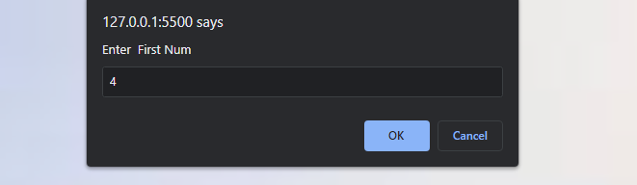

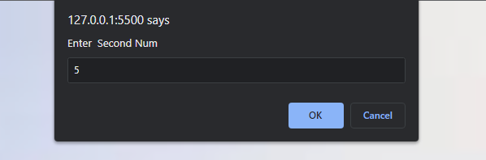

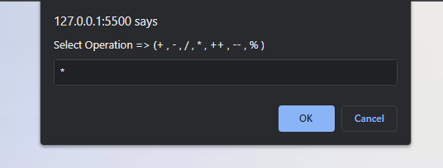

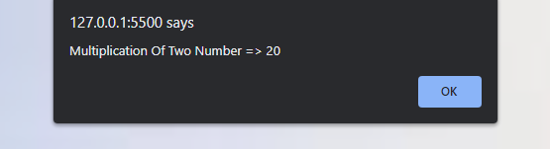

**Task 02: var array = ["Banana", "Apples", "Oranges", "Blueberries"];  
1. Remove the Banana from the array.  
2. Sort the array in order.  
3. Put "Kiwi" at the end of the array.  
4. Remove "Apples" from the array.  
5. Sort the array in reverse order. (Not alphabetical, but reverse// the current Array i.e. ['a', 'c', 'b'] becomes ['b', 'c', 'a'])**

**Solution:**

**Task2.html**

<!DOCTYPE html>

<html lang="en">

<head>

    <meta charset="UTF-8">

    <meta http-equiv="X-UA-Compatible" content="IE=edge">

    <meta name="viewport" content="width=device-width, initial-scale=1.0">

    <title>Task2</title>

    <style>

        a {

            text-decoration: none;

            padding: 10px;

            font-size: larger;

            color: #000;}

        a:hover {

            background-color: blue;

            color: white;

            border-radius: 50%;

        }

    </style>

    <link rel="stylesheet" href="Style.css">

</head>

<body>

    <main>

        <div style="display: flex;justify-content: center;margin: auto;">

            <div style="display: flex;justify-content: center;margin: auto;">

                <a href="index.html">Home</a>

            </div>

        </div>

    </main>

    <script src="task2.js"></script>

</body>

</html>

**Task2.js**

var array = ["Banana", " Apples", " Oranges", " Blueberries"];

document.write(" <b>Array:</b> "+array +"<br> <br>");

array.shift();

document.write("<b>1) Remove Banana [Using Shift()] Method: </b> "+array +"<br> <br>");

array.sort();

document.write("<b>2) Sort Array [Using Sort()] Method: </b> "+array+ "<br> <br>");

array.push("kiwi");

document.write("<b>3) Add kiwi [Using Push()] Method: </b> "+array + "<br> <br>");

array.shift();

document.write("<b>4) Remove Apple [Using Shift()] Method: </b> "+array+ "<br> <br>");

array.reverse();

document.write("<b>5) Sort Array [Using Reverse()] Method: </b> "+array+ "<br> <br>");

var array = ["Banana", "Apples", "Oranges", "Blueberries"];

**Output**

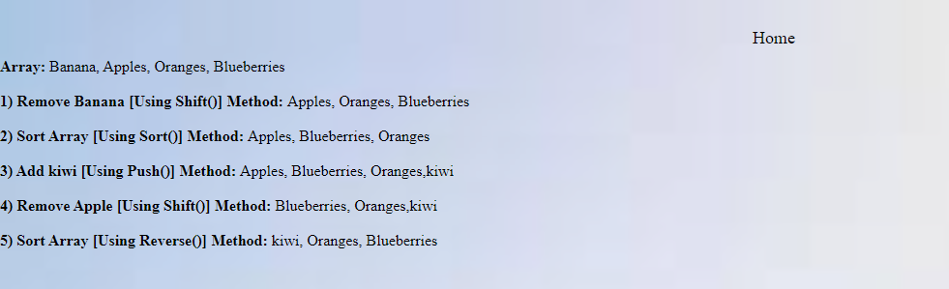

**Task 03: I Suppose by default there is a prompt saying “ Alarm is ringing”. Press ‘S’ to snooze and ‘D’ to dismiss  
II If user selects ‘D’, program will be dismissed with a prompt “Good Morning”  
III If user select ‘S’ , the program “ Alarm is ringing”. Press ‘S’ to snooze and ‘D’ to dismiss will rerun and again the prompt will be (repeat from step I)  
IV upon entering wrong input program will prompt “wrong input” and program ends.**

**Solution:**

**Task3.html**

<!DOCTYPE html>

<html lang="en">

<head>

    <meta charset="UTF-8">

    <meta http-equiv="X-UA-Compatible" content="IE=edge">

    <meta name="viewport" content="width=device-width, initial-scale=1.0">

    <title>Task3</title>

    <style>

         a {

            text-decoration: none;

            padding: 10px;

            font-size: larger;

            color: #000; }

        a:hover {

            background-color: blue;

            color: white;

            border-radius: 50%;}

    </style>

    <link rel="stylesheet" href="Style.css">

</head>

<body>

    <main>

        <div>

            <div style="display: flex;justify-content: center;margin: auto;">

                <a href="index.html">Home</a>

            </div>

        </div>

    </main>

    <script src="task3.js"></script>

</body>

</html>

**Task3.js**

var alaram = prompt(" “Alarm is ringing”. Press ‘S’ to snooze and ‘D’ to dismiss");

if(alaram==='S' || alaram==='s')

{

   while(alaram==='S' || alaram==='s')

   {

    alaram = prompt(" “Alarm is ringing”. Press ‘S’ to snooze and ‘D’ to dismiss");

   }

}

else if(alaram==='D' || alaram==='d')

{

    alert("Good Morning ")

}

else

{

    alert("Wrong Input Provided");

}

**Output**

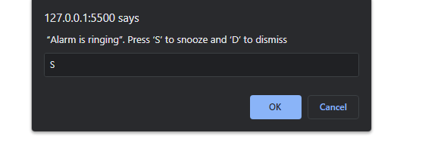

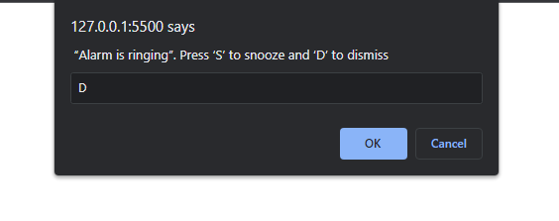

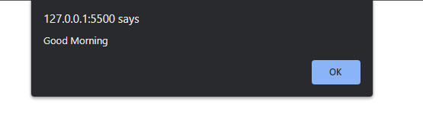

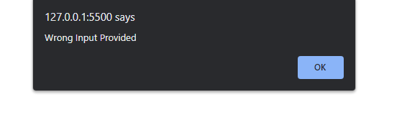

**Task 04: Create an object and an array which we will use in our facebook exercise.   
Create an object that has properties "username" and "password". Fill those values in with strings.  
Create an array which contains the object you have made above and name the array "database".  
Create an array called "newsfeed" which contains 3 objects with properties "username" and "timeline".**

**Solution:**

**Task4.html**

<!DOCTYPE html>

<html lang="en">

<head>

    <meta charset="UTF-8">

    <meta http-equiv="X-UA-Compatible" content="IE=edge">

    <meta name="viewport" content="width=device-width, initial-scale=1.0">

    <title>Task4</title>

    <style>

       a {

            text-decoration: none;

            padding: 10px;

            font-size: larger;

            color: #000;

        }

        a:hover {

            background-color: blue;

            color: white;

            border-radius: 50%;

        }

    </style>

    <link rel="stylesheet" href="Style.css">

</head>

<body>

    <main>

        <div>

            <div style="display: flex;justify-content: center;margin: auto;">

                <a href="index.html">Home</a>

            </div>

        </div>

    </main>

    <script src="task4.js"></script>

</body>

</html>

**Task4.js**

document.write("<b>1) Object</b><br>");

var Data = {

    username: "M Muaz Shahzad",

    password: "Muaz 123"

  };

document.writeln("<br><b> Username :</b> "+Data.username +'<br>')

document.writeln("<b> Password :</b> "+Data.password +'<br>')

document.write("<br><b>2) Array</b> <br>");

var database=[Data]

document.writeln("<br>"+ database[0].username +"<br>")

document.writeln( database[0].password +"<br>")

var newsfeed=[{

    username: 'M Muaz Shahzad',

    timeline: 'Available'

},

{

    username: 'Talha',

    timeline: 'Not Available'

},

{

    username: 'Shahab Tahir',

    timeline: 'Available'

}]

document.write("<br><b>3)Array Of an Object</b> <br> <br>");

document.write("<b> Username :</b> "+newsfeed[0].username +"<br> "+ "<b>TimeLine: </b> "+newsfeed[0].timeline+"<br> <br>")

document.write("<b> Username :</b> "+newsfeed[1].username +"<br> "+ "<b>TimeLine: </b> "+newsfeed[1].timeline+"<br><br> ")

document.write("<b> Username :</b> "+newsfeed[2].username +"<br> "+ "<b>TimeLine: </b> "+newsfeed[2].timeline+"<br><br>")

**Output**

